Connect to Cerner’s Patient Portal – Android/iPhone
Did you know that you can access your patient portal via the Coral Health app? In a few easy steps, you can easily connect to the patient portal and receive information such as your medications, immunizations, lab results, and more.

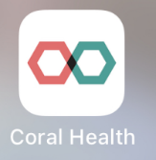
Add your health records
- Download the Coral Health app to your phone and open.

- Click on the magnifying glass icon and search for Southwest Memorial Hospital. Tap on it.

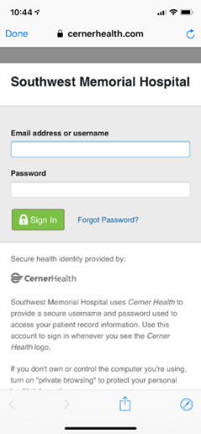

- Sign in to the portal using your email address and password.

