Connect to Cerner’s Patient Portal - iPhone
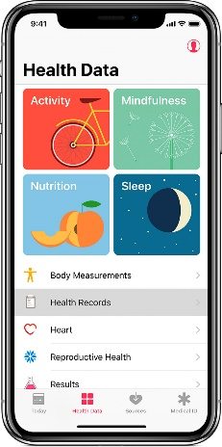
Did you know that you can access your patient portal via the Health app on your iPhone? In a few easy steps, you can easily connect to the patient portal and receive information such as your medications, immunizations, lab results, and more.

Add your health records
- Open the Health app, then tap the Health Data tab.

- Tap Health Records > Get Started.

- Search for Southwest Memorial Hospital, then tap it.

- Under Available To Connect, choose Southwest Memorial Hospital. Then click Add health records
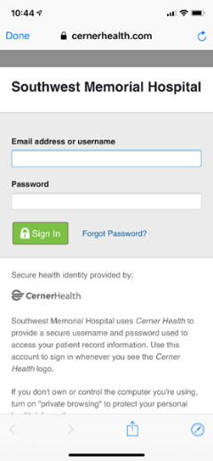
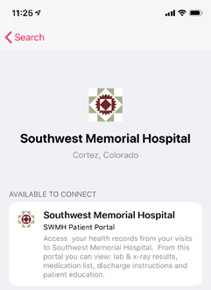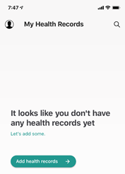

- Sign in to the portal using your email address and password.

